CGRA 350 Assignment 2 – Jackson Tume

300446258

# **Part 1:** Skeleton rendering and animation

*Core:*

Brief introduction:

The code is pretty much all in the skeleton_model drawBone() function. The function first finds the location of the joint using the direction and length of the bone. It then draws the axes and rotates them using the bones basis. The function then uses the joint’s location to calculate the orientation of the bone using the current bones direction. The function recursively calls this function on every bone.

How to run:

The program will run and display the character in the T pose automatically.

*Completion:*

Brief introduction:

To get different poses, I created a file to manually adjust the bone positions into the desired location. Then using simple Booleans to show which pose the character should display.

How to run:

To change to the character into different poses, simply use the imGUI checkboxes to display different poses on the character.

*Challenge: *Not Attempted\**

**\*High resolution photos of results are included with submission\***

# **Results:**

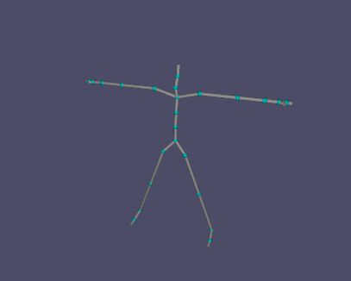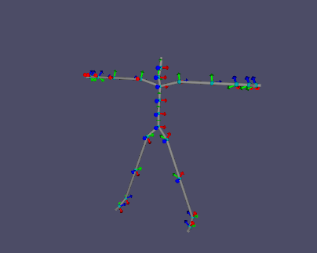

Core with axes

Core without axes

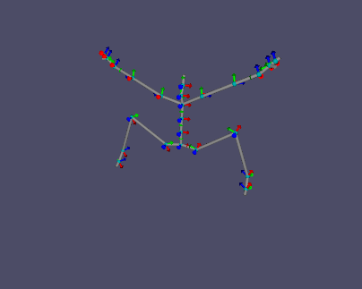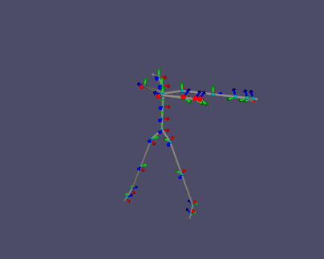

Dabbing Pose

Jumping Pose

Walking Pose

Seated Pose

Punching Pose

